Augmented Reality

-*Aman Garg, BVCOE*

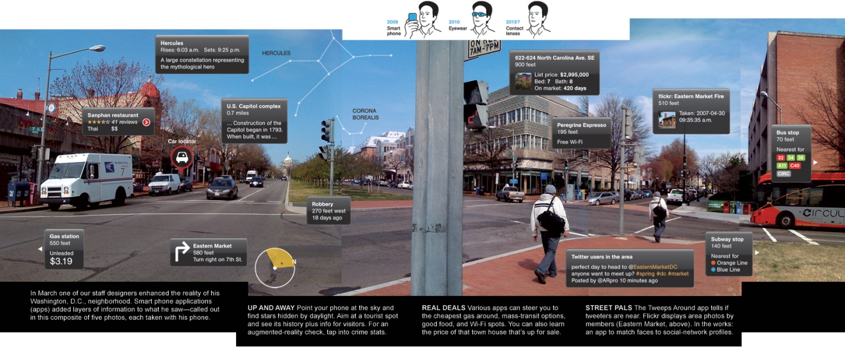For a digitally enhanced view of real environment, a new technology i.e., Augmented reality is here by which we can get a digitally modified view of physical and real time environment which increases user’s virtual perception. This technology senses input signals like sound, videos, graphic etc. using sensors technology available on devices and provide its enhance and descriptive view digitally. It brings the virtual world to the reality with a new 3-D experience. In Augmented displays all graphics, videos, elements appears with description along with the audio output.

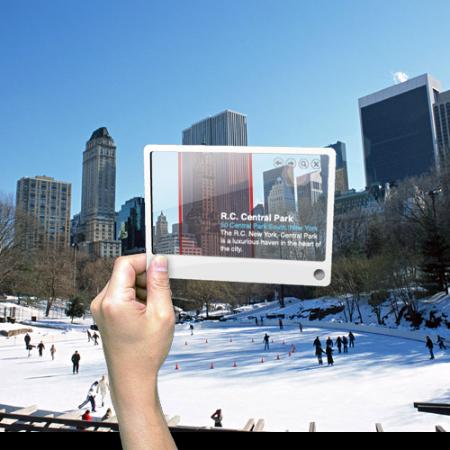In today’s scenario, there are so many smart applications available which are integrated with this technology and present the best use of augmented reality technology. Some of the popular applications of Augmented Reality are QR-Code Reader, Word lens, AR Compass, Google Glasses etc. which have made a very impressive impact on modern technology.

Another most widely increasing application of augmented reality is in ‘Virtual Gaming’. In Gaming, augmented technology allows user to conquer territory virtually by allowing graphic from screen to pull in the real world which is a attracting a mass population of users toward virtual world of Augmented Reality. Other best use of the technology is conversion of different foreign languages into tourist’s local understandable language by just a virtual input of description, signal and other useful documents.

With the modernization of technology, Augmented Reality is integrating the new virtual world to real physical world with so many new impressive features and functions which is the point of attraction for every technology enthusiast.